**Write an R program to create a vector, a matrix and a data frame.**

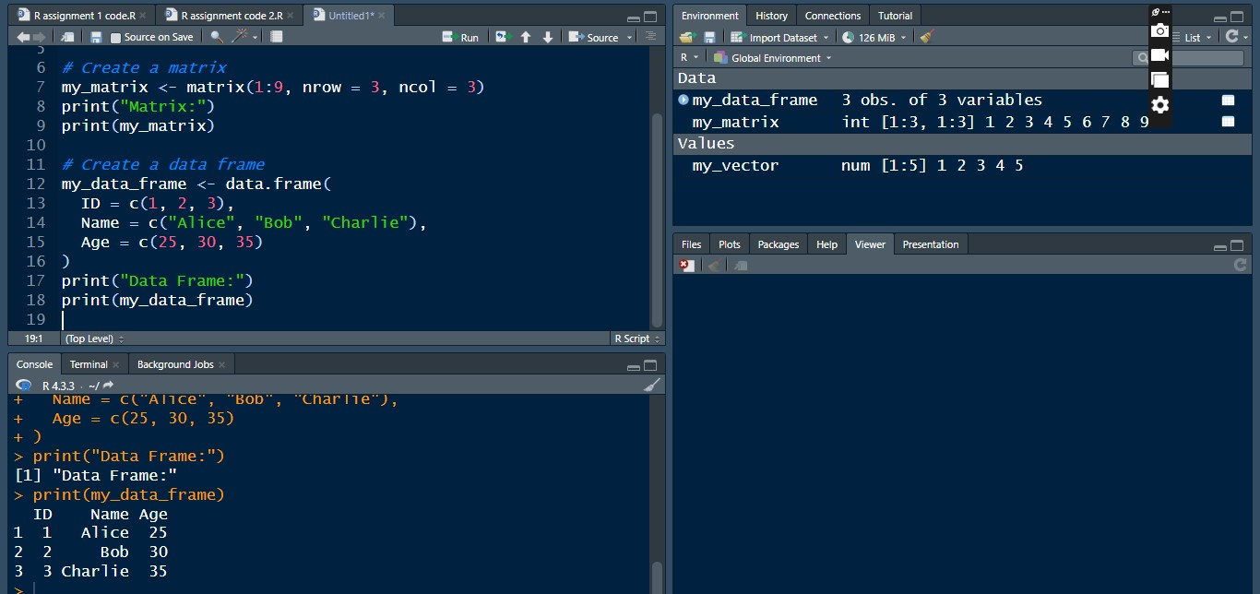

**Create a list from the above created data programs**

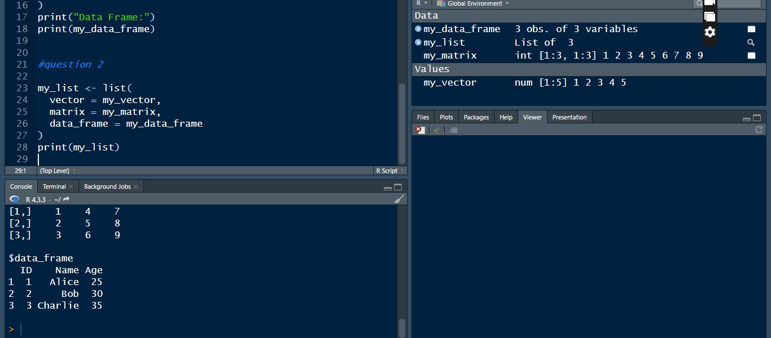

**Sort your data frame in descending order**

